# MCBMiniCom v1.4 – Scalable and Flexible Motor Control

The MCBMiniCom board serves as a communications board for the MCBMini motor control project. It provides a flexible way to communicate with a stack of MCBMini boards, providing options such as USB, Bluetooth, XBee and TTL level serial.

The purpose of the MCBMiniCom board is to relay communications from a host computer (via either USB, TTL serial, Bluetooth or XBee) to the RS-485 bus with the MCBMini motor controllers. It also serves to provide logic power to that bus, either from a separate power source (Vin connector) or from the main power terminals used to power the motors (through a diode and large capacitor filter).

The MCBMiniCom v1.4 board has connectors, which are compatible with the BlueSMiRF and XBee boards from Sparkfun to provide wireless communications with the motor controllers.

Here is a picture of the previous version of the MCBMiniCom v1.3 board:

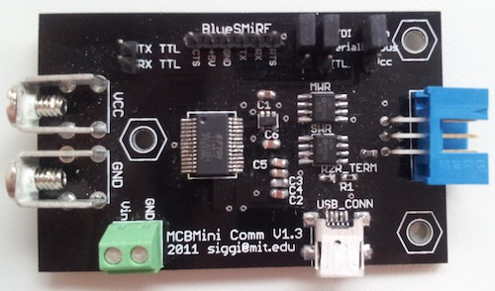

A PCB design layout of the MCBMiniCom board V1.4:

